Lab Report walkthrough - 4.6.5

Title: Packet Tracer – Physical Layer Exploration: Connect a Wired and Wireless LAN

Objectives
The objectives of this lab were:
- To connect network devices using the correct cable types.
- To configure and verify IP addressing based on a predefined addressing table.
- To establish WAN connectivity between routers.
- To integrate wired and wireless LAN networks.
- To verify network connectivity using diagnostic commands.
- To explore and analyze the physical topology view.

Network Topology Description
The network consists of the following components:
- Cloud (ISP simulation)
- Cable Modem
- Router0 (Core Router)
- Router1 (Branch Router)
- Switch (Wired LAN)
- Wireless Router (Home Gateway)
- Family PC
- Home PC
- Home Printer
- netacad.pka (Server)
- Configuration Terminal
The topology integrates multiple subnetworks connected through routers and WAN links.
IP Addressing Scheme
The following addressing table was implemented: -
Device | Interface | IP Address
Router0 | F0/0 | 192.168.2.1/24
Router0 | F0/1 | 10.0.0.1/24
Router0 | S0/0/0 | 172.31.0.1/24
Router1 | S0/0 | 172.31.0.2/24
Router1 | F1/0 | 172.16.0.1/24
Wireless Router | Internet | 192.168.2.2/24
Wireless Router | LAN | 192.168.1.1
Family PC | F0 | 192.168.1.102
Switch | VLAN | 172.16.0.2
Netacad.pka | F0 | 10.0.0.254
Each subnet was logically separated to ensure proper routing between networks.

Implementation Procedure
Part 1: Connect to the Cloud
- Router0 F0/0 was connected to Cloud Eth6 using a Copper Straight-Through cable.
- Cloud Coax7 was connected to Cable Modem Port0 using a Coaxial cable.
- Link lights were verified to ensure successful connections.
This simulated ISP connectivity between the internal and external networks.

Part 2: Connect Router0
- Router0 S0/0/0 was connected to Router1 S0/0 using a Serial cable.
- Router0 F0/1 was connected to Netacad.pka using a Cross-Over cable.
- Router0 Console was connected to the Configuration Terminal using a Console cable for management access.
These connections established WAN communication and server access.

Part 3: Connect Remaining Devices
- Router1 F1/0 was connected to the Switch using a Copper Straight-Through cable.
- Cable Modem Port1 was connected to the Wireless Router Internet port.
- Wireless Router Ethernet1 was connected to the Family PC.
- The Home PC and Home Printer were connected wirelessly.
This step integrated both wired and wireless LAN environments.
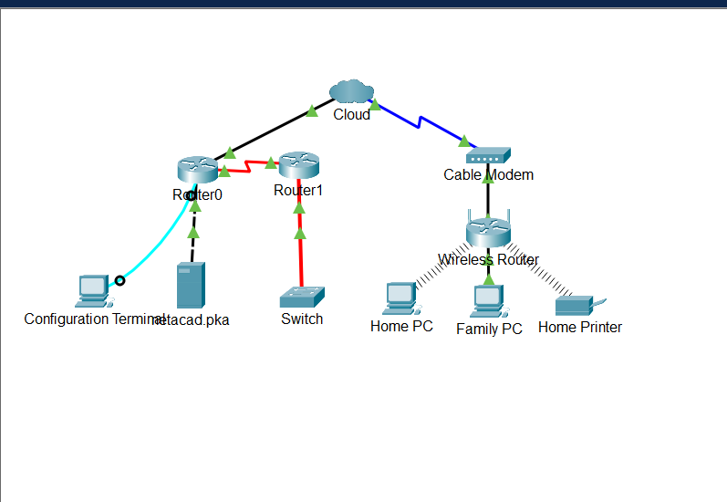

Part 4: Verification of Network Connectivity
Step 1: Testing Connectivity from Family PC
Command used: ping netacad.pka
Result:
- Successful replies received.
- No packet loss observed.
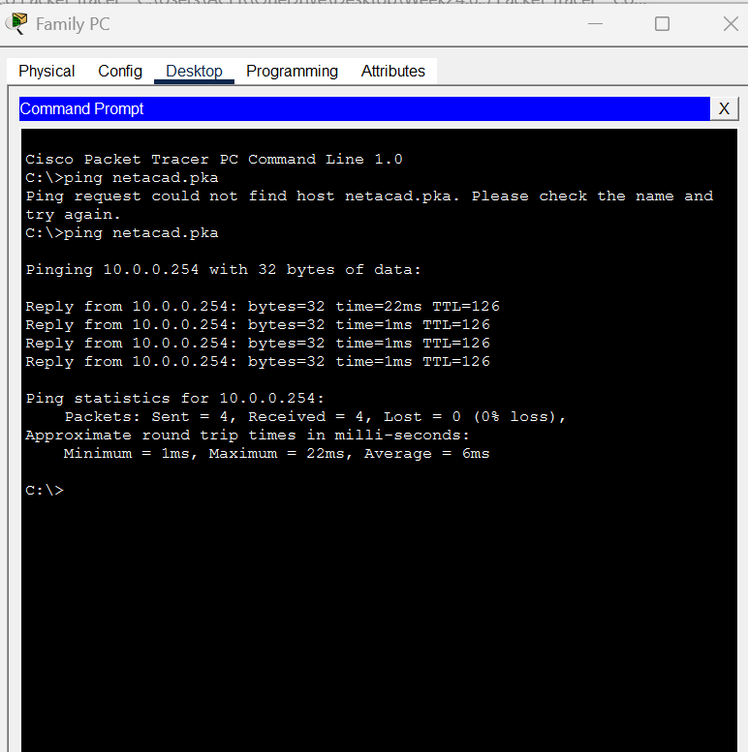

Web browser test: http://netacad.pka
The webpage opened successfully, confirming HTTP connectivity.
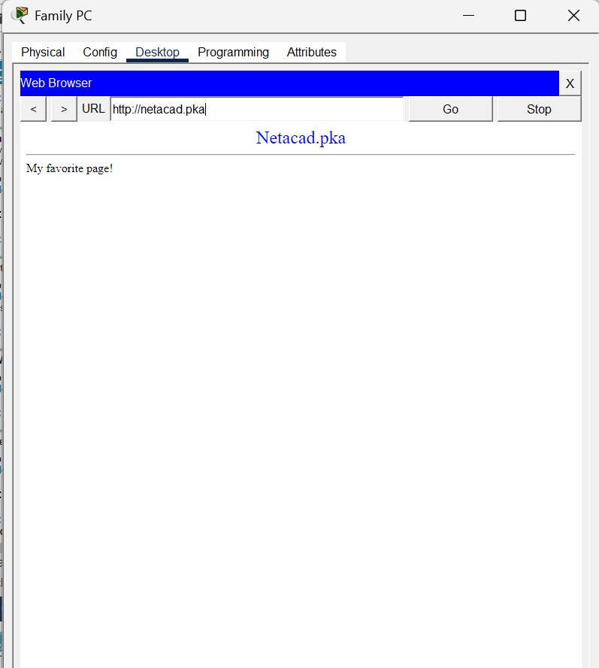

Step 2: Testing Connectivity from Home PC
Command used: ping 172.16.0.2
Result:
- Replies received.
- End-to-end connectivity confirmed.
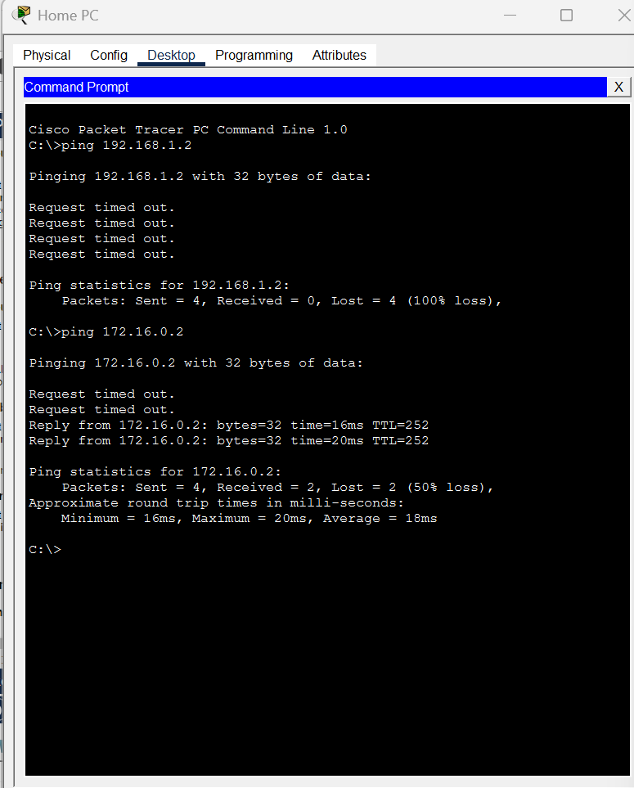
Step 3: Verifying Router Interfaces
From Configuration Terminal:
- Enable
- show ip interface brief
Output confirmed:
- FastEthernet0/0 – up/up
- FastEthernet0/1 – up/up
- Serial0/0/0 – up/up
All necessary interfaces were operational.
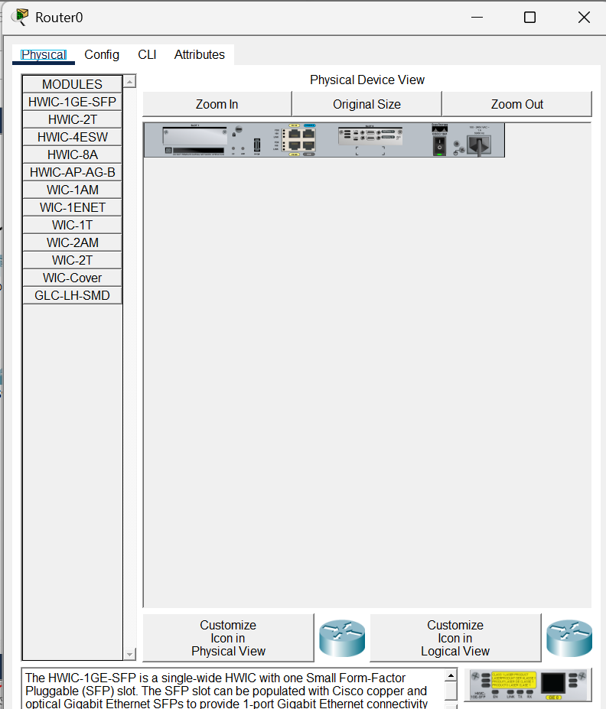
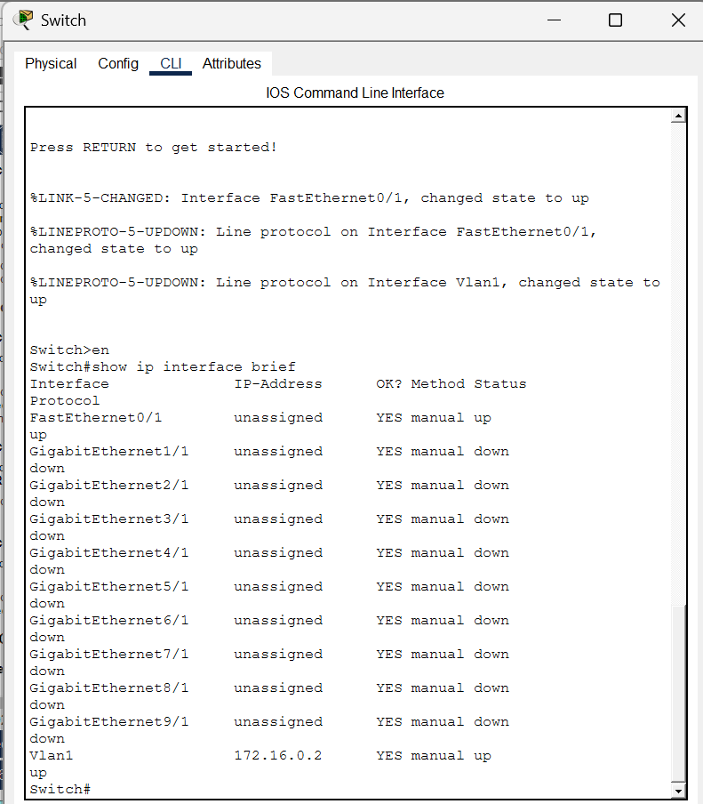

Part 5: Examination of Physical Topology
In the Physical Workspace:
- The Cloud rack contained a connected switch and power distribution equipment.
- The Primary Network showed rack-mounted enterprise devices.
- The Secondary Network displayed dual orange fiber cables representing transmit (Tx) and receive (Rx) paths.
- The Home Network did not include a rack because home environments typically use small, standalone networking devices rather than structured racks.
This comparison demonstrated the structural differences between enterprise and residential network setups.
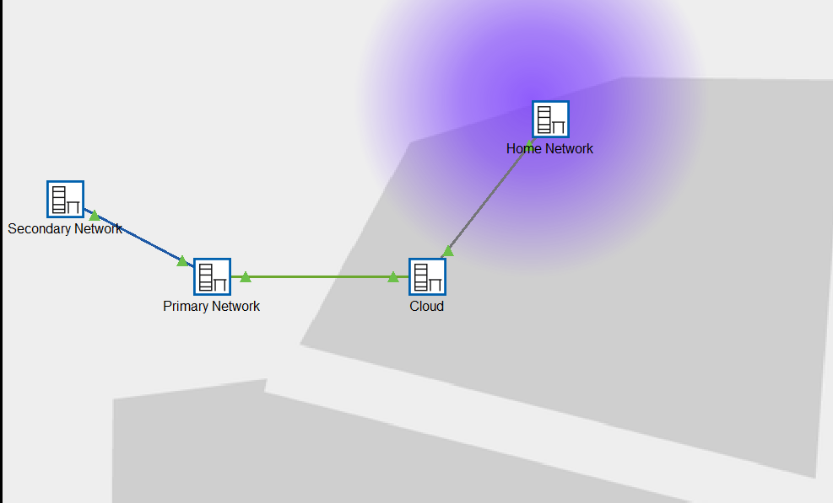
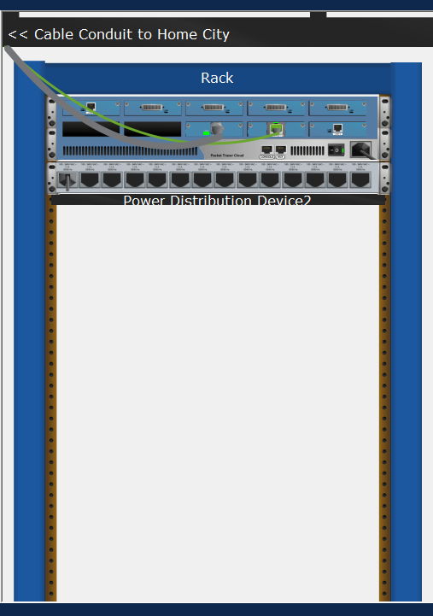
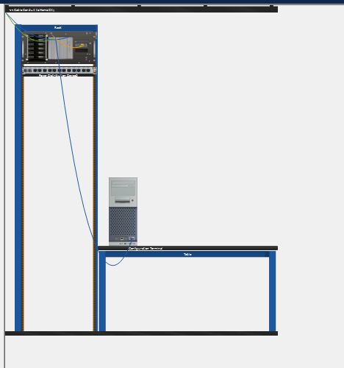
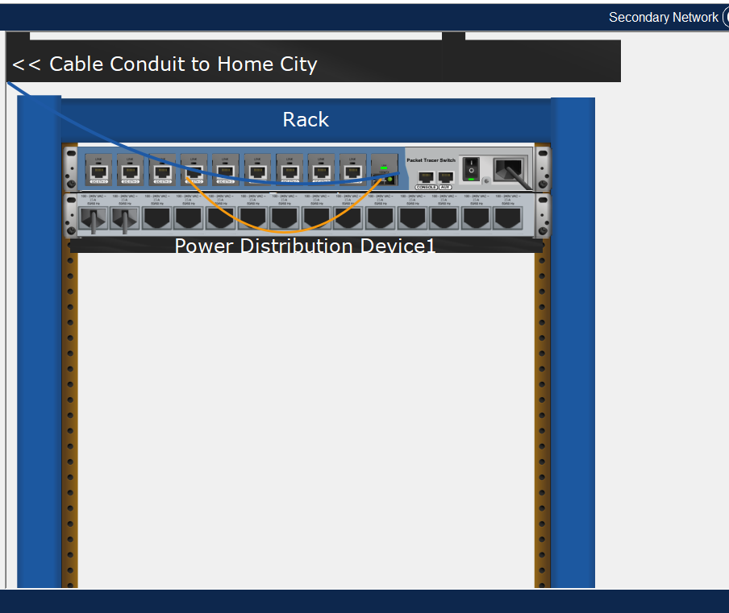
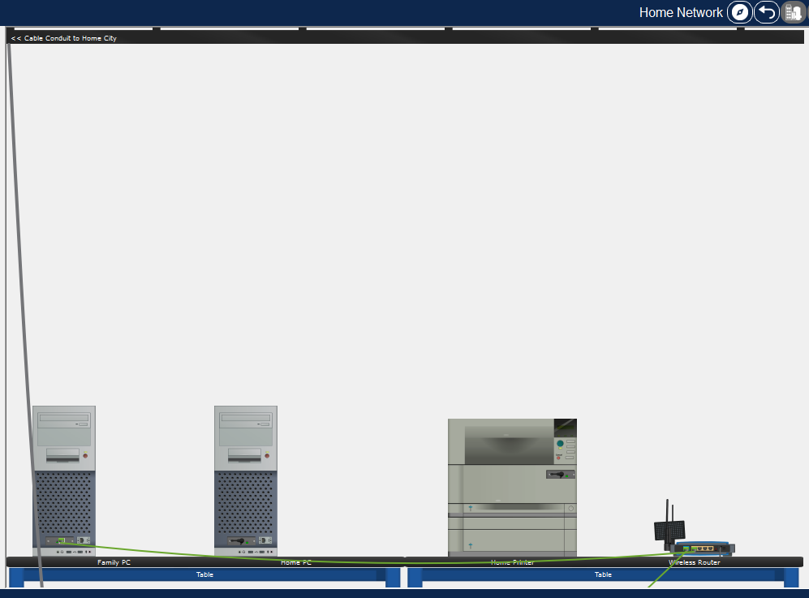

Data Flow Analysis
The communication path from the Family PC to the server is as follows:
Family PC
→ Wireless Router
→ Cable Modem
→ Cloud
→ Router0
→ Router1
→ Switch
→ Destination Network
This confirms successful routing between wireless and wired LAN segments.

Conclusion
This laboratory exercise successfully demonstrated the integration of wired and wireless LAN networks within a routed environment.
The following were achieved:
- Correct selection and use of network cables.
- Proper IP addressing configuration.
- Successful WAN routing between routers.
- Verified end-to-end connectivity.
- Clear understanding of logical and physical network topologies.
All lab objectives were met, and the network operated as expected.

